Afrika Korps Rule Clarifications
Revised
November 9, 2023

Playable Hexes
Qattara Depression Partial Hexes: The following are playable hexes: Q59-Q64; R58, R59, R65; S57, S58, S61-S65; T56, T57, T62; U55, U56, U62; V55, V61, V62; W54, W55, W61, W62; X54, X62, X63.

Hexes Not Adjacent: The following pairs of hexes are examples of anomalous hexes pairs that are not adjacent. Movement directly between them is not possible and unaccompanied Supply units are not affected by enemy units across the anomalous hex sides: E18-F19; R65-S65; W61-X62; W62-X62.

Unplayable Hexes - East Edge: Unplayable hexes: H63, I64, J64, K65, L65, M66, N66, O67, P67, Q68, R68, S69, T69, U70, V70, W70, X70.

Playable Hexes - South Edge: Units may not enter the southern-most row on the board, because there is no "Y" grid coordinate.

Movement With Rommel
Question - Rule 22.1 and the Rommel bonus on Turn 1: Rommel moves 2 hexes with units at El Aghelia from W6 to W8. Would they still have 10 more hexes along the road plus their regular movement?

Answer - Yes.

The Rommel Bonus could be taken while traveling with Rommel, or the bonus could be taken later, even as the last two hexes of movement and even if Rommel is not with the units at the instant that they take the bonus, as long as Rommel moved with them for two hexes at some point during the turn.

Furthermore, the combat units could move first and fully expend their movement, then Rommel could join them while he still possesses movement and add the two hex Rommel Bonus as he travels with them.

Per 22.1: The Rommel Unit provides any and all friendly units a two hex movement bonus provided it moves with that unit(s) for two hexes. If Rommel only moves with a unit for one hex, then the unit only receives a one hex bonus. Note that the rule does not state that the bonus must be taken while Rommel is traveling with the unit.

Supply Capture and Movement After Capture

Supplies captured during movement including Automatic Victory may be moved normally and used to sustain combat.
Figure 1 is a capture during normal movement. In Figure 2, the supply is captured during an AV. In both cases, the supply may be moved and used to sustain attacks including the AV allowing its capture.

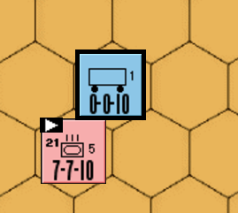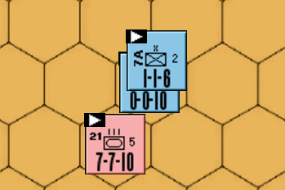
Figure 1 Figure 2

Question: In Figure 3, may a single Brit 1-1-6 combat unit move to Q13 to capture an unaccompanied Supply Unit.

No. The movement is illegal. The British 1-1-6 cannot voluntarily place itself in an attack situation that is not allowed. As a result, the limitations of 7.4 supersede the automatic capture rules of 15.21 and 15.22.
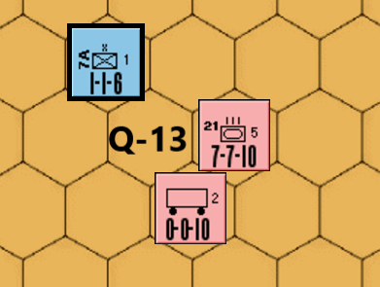
Figure 3

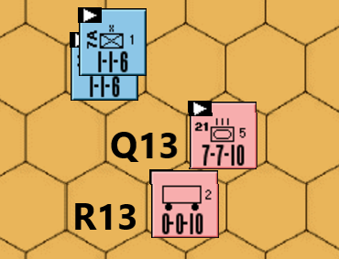
Figure 4

If two Allied 1-1-6 combat units move to Q13 (Figure 4), then it is a legal attack and 15.21 would apply. The Supply can be moved after capture and used to support combat.

Supplies captured during regular combat may be moved normally but not used to sustain combat.
In Figure 5, 21/5 and 21/3 if in supply may attack 9A/20. The attack is guaranteed to be successful allowing the supply to be captured. The captured supply may be moved but not used to sustain attacks.
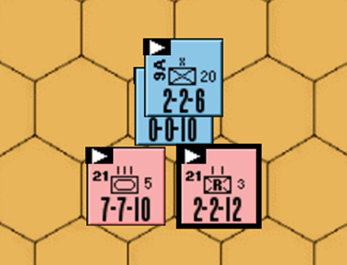
Figure 5
In Figure 6, one Axis unit may attack the 7/4 armor if supplied while the other Axis unit attacks the supply capturing it. That supply may be moved but not used to sustain combat. If no unit is supplied for the 1-2 attack vs 7/4, then the attack is illegal, and the other unit may not attack the supply.
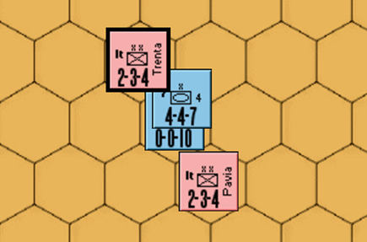
Figure 6

In Figure 7, may 7A/1 attack Ariete and 4I/11 attack the supply, thus capturing it?

Yes. The supply unit is captured if one adjacent enemy combat unit attacks the supply, while other units attack the combat units at legal odds (1-6 or better). Attacks of 1-2 or better would require a supply.The attacker may not use more than one attacking unit to capture the supply per Rule 15.322; all other units in the defender’s ZOC must attack the combat units while in supply.

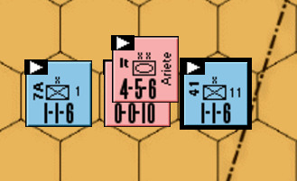
Figure 7

Supplies captured through movement after combat (advancing or retreating), may only be moved to join the capturing unit and may not be used to support combat.
In Figure 8, 21/5 and 15/8 attack 50 6SA Motor with an AV. They capture the supply if one or both units advance after combat. The captured supply may then be moved to join the capturing unit(s) at the Axis player option.

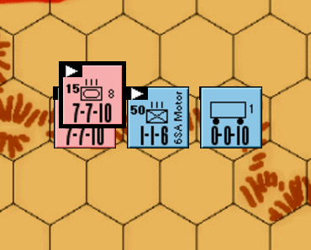
Figure 8

In Figure 9, 21/5 may attack the supply in the fortress, but its ZOC does not extend into the fortress. Therefore, the supply is not automatically captured. 21/5 may advance after combat to capture it but the supply may not be moved. A different Axis unit could of course move into the fortress, capture it, move the supply normally and sustain combat with it.

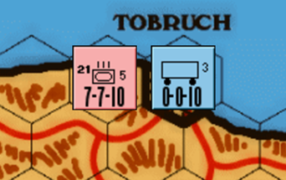
Figure 9

In Figure 10, 21/3 may attack both 9A/20 and Supply 3. If 9A/20 is eliminated or retreated, 21/3 may move into Tobruch to capture the supply. The captured supply may not be moved or used to sustain combat.

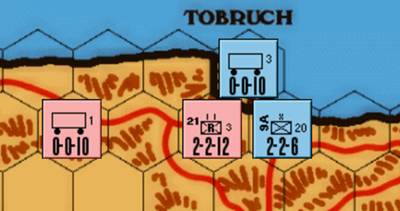
Figure 10

In Figure 11, 2/3 is adjacent to Tobruch and a supply is in Tobruch.

Question: In Figure 11, may three Italian 2-3-4 Combat Units move adjacent to both and have two units attack Tobruch (defended only by the supply) while one soaks off against the 4-4-7, so that one unit advances into Tobruch capturing the supply, one stays outside and adjacent to the 4-4-7 and the third has combat vs the 4-4-7?

Answer: No. Although the situation is not exactly as described in 15.322, the following ruling is based upon 15.322: The supply unit is captured if one adjacent enemy combat unit “attacks” the supply, while other attacking units attack the … combat units at legal odds (1-6 or better). The attacker may not use more than one attacking unit to capture the supply; all other units in the defender’s ZOC must attack the combat units.

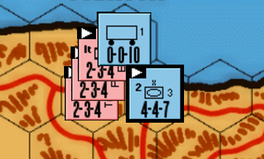
Figure 11

Other Supply Capture & Move Questions.

In Figure 12, may 21/104 move to P57, capture the supply, move it to R58 and move the 7-7-10 to R58 for an AV?

No. 21/104 is not allowed to move to P57, since it must be in supply to make a 3-1 attack. The Allied 50/69’s ZOC at P56 & P57 blocks a 5-hex path free of enemy ZOC for 21/104’s to make the attack.

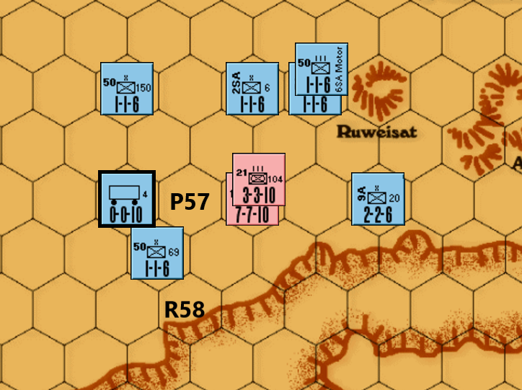
Figure 12

In Figure 13, May the Allied 2/3 move to K35, attack the supply, capture it and not attack 21/3 while 4I/11 attacks 21/3 @ 1-4?

No. Unaccompanied supply units may be “attacked” if they are in a fortress – Rule 15.23. There is no mention of “attacking” an unaccompanied supply otherwise. If not in a fortress, they are simply captured per 15.21. Therefore, 2/3 must attack any enemy unit within its ZOC. It does not change anything if the supply is at J35 instead of J34. If 2/3 moves into a ZOC of 21/3, it must attack.
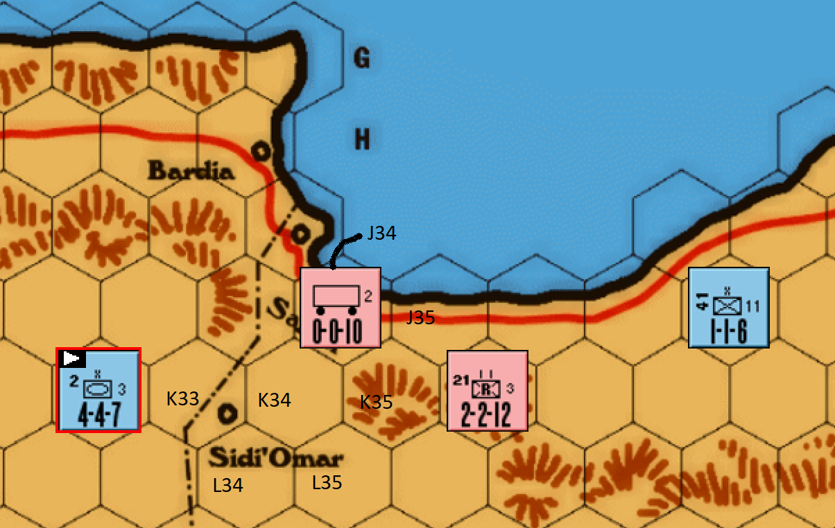
Figure 13

In Figure 14, may the Allied recce unit use supply 1 to attack the 21/3?

No. Although Rule 13.2 allows an unaccompanied supply to be adjacent to an enemy unit, this violates Rule 14.2 since the board edge and 21/3 ZOC blocks a 5-hex path free of enemy ZOC.

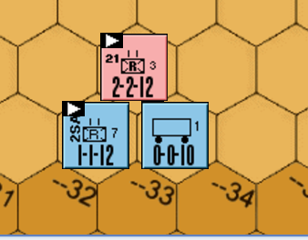
Figure 14

In Figure 15, may the Allied recce unit use supply 1 to attack 21/3.

Yes Rule 13.2 allows an unaccompanied supply to be adjacent to a unit being attacked and there is a 5-hex path free of enemy ZOC per Rule 14.2.

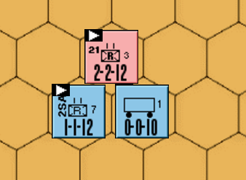
Figure 15

Trapped Units
In Figure 16, two Allied units are trapped after Axis attacks. Can the two trapped Allied units be saved?

The Allies units are isolated in enemy ZOC hexes. They may not attack at odds of 1-2 or better without supply. Rule 11.9 requires their removal before any other combat if they cannot make legal attacks. If the Allies can gain an automatic victory over 21/104 or 21/5 with non-trapped units. AVs occur during the movement phase, and the trapped units would then be able to move and attack normally.

If the Allies cannot gain an AV, then one of the trapped units can attack 21/5 at odds of worse than 1-2 which requires no supply – presumably the 3-3-7. There are no other legal attacks for the other trapped unit, and it would have to be removed prior to any combat per Rule 11.9. The Allies can also attack 21/104 with non-trapped units. The trapped unit attacking 21/5 (at worse than 1-2) can block 21/104s retreat and then attempt to gain a retreat with its attack.
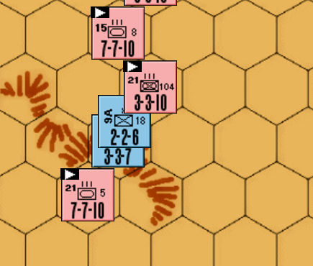
Figure 16

Attacking Rommel in Tobruk

Question: If the Rommel unit is in Tobruk without any other units, can he be "attacked" for the purpose of putting him in a unit’s zone of control and thus moving him to the nearest Axis unit? Example, Rommel is alone in Tobruk and a 1-1-6 moves to G24. Can the 1-1-6 "attack" Rommel during the combat phase of the turn to place him in his zoc resulting in Rommel being placed with the nearest Axis unit. If the answer is yes, would rule 16.3 also apply, which would allow the 1-1-6 to advance after combat into the fortress?

Answer: No and No. Per 22.4 - Rommel cannot be attacked, captured or eliminated.

Attackers Being Retreated Into Isolation

Question: The Axis have several Brit units encircled & isolated. Two British units attack Axis units at 1-3 resulting in AB2. Two routes are available for retreat. One route puts them back inside isolation. There are plenty of hexes available without running into blocking terrain or Axis ZOC. The second route is outside the encirclement, which would thus free them from isolation. Does rule 7.62, (i.e., you cannot force a unit into terrain which would result in its elimination), mandate that the units must be retreated outside of the encirclement.

Answer: No. Rule 7.62 does not apply. Rule 7.62 covers situations whereby the retreat would cause immediate elimination, not eventual elimination due to lack of supply. Rule 24.2 is applicable to the situation, and it allows the retreat of the units back into isolation.

Essentially, the winner of the battle may not retreat units in a manner that causes the immediate elimination of any unit in that same battle, if there are other possibilities that permit all retreating units to live after the retreat is completed. The winner may retreat a losing unit into an isolated position that will cause its eventual elimination.

Isolated Even When Stacked with A Supply Unit

Question: The Axis isolate the Allied home base with an Allied combat unit occupying the home base. The Allies land a supply at their home base on top of the allied combat unit, but then destroys the supply after movement to prevent it from being captured. Is the unit occupying the home base considered to have been supplied for that turn?
Answer: No. It is counted as a turn of isolation, because the unit was isolated at the beginning of the turn AND at the end of the turn. In order for it not to count as a turn of isolation, the unit must be in supply at the beginning of a turn OR at the end of a turn.

Retreating Back into Original Hex

Question: An allied unit in Tobruk attacks an Italian unit on H26 and rolls an AB2. May the winner of the battle retreat the attacker to G24 then back into Tobruk?

Considerations: This situation is not specifically listed in the rules, but Rule 7.6 states that Retreats can be handled in a zigzag fashion so as to end the retreat only one hex away from the original hex occupied during the battle. However, the common ruling for AH games is that a retreating unit cannot end up in the same hex from which it started, nor can it retreat into the same hex twice.

Answer: No, an attacking unit cannot retreat back into the hex from which it attacked. A defending unit cannot retreat back into the hex in which it was attacked. If no other legal retreat is available, such unit(s) are eliminated. Rule 7.6 specifies that retreats can be handled in a zag-zag fashion so as to end the retreat only one hex away from the original hex, but it does not specify “so as to end the retreat in the original hex.”

Supply And Automatic Victory

Rule 9.7 The supply used to sustain an AV attack could conceivably move over the AVed unit and continue on to supply other attacks on the same turn but it must maintain its five hex supply line to the units which made the AV attack as well as any units involved in other attacks which it is supplying (Exception: See 14.5).

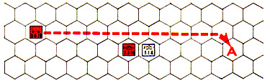
Figure 17

EXAMPLE: 21/5 has established an AV (7-1) vs 7A/2. The German unit is within five hexes of supply #1. The 21/5 must remain in position for the rest of the turn, although the supply can move as shown to hex “A”, ignoring 7A/2’s ZOC and ending its movement still within five squares of21/5. Note the reverse is not true: if supply #1 had started the turn at “A” it could not supply the AV from that hex, since the 7A/2’s ZOC is not ignored until after the supplied AV has taken place.

Rule 14.5 Supply units are required to sustain AV attacks both at the instant the AV is attained and at the end of the movement portion of the attacking player’s turn. Note that it is possible that the supply unit sustaining an AV attack may move out of the five hex supply radius of that attack, providing another supply unit takes its place within the five hex supply radius at the end of the movement portion of the turn. However, in this case both supplies would have to be used to sustain the AV attack.

Rule 14.6 The attacking player must state before resolving each combat (including AV attacks) which supply is sustaining the attack.

So, the attackers move adjacent to the first defender. Combat does not occur until the end of movement; at which time a supply unit must be within 5 hexes of the attackers.

However, AVs are not normal combat. At the instant a supply unit arrives, an attack may qualify as an AV (flip the Av’ed units) - then the supply unit may continue right on through the AV. Once that supply unit stops moving, other units may also pass through the AV. The moving supply unit could even move on to supply other AV’s or normal attacks.

The AV becomes viable at the instant the Supply unit moves within five hexes of all the attackers – note that the original defenders ZOC will block the supply route, so you cannot trace the initial 5 hex path through the original defenders ZOC. But as soon as the AV becomes viable, the original defenders ZOC ceases to exist. See 9.6 - The original path cannot be through the defenders ZOC, but the final path at the end of the movement phase may be through the defenders ZOC.

The moving supply unit that makes the AV viable may continue past the AV hex to supply another different AV or future normal combat. This is Okay as long as the supply units keeps on moving – the supply unit cannot be moved twice – no other unit may move while the supply unit is moving unless they have been traveling together the whole time. But, for the sake of clarity, it is necessary for the attacker to halt the supply unit momentarily so that he can show the defender the legal 5 hex supply path that makes the AV viable – then the supply unit resumes movement.

At the end of all movement ANY supply unit must be within five hexes of the original overrunning units (ignoring the original defenders ZOC at this point). If the unit providing supply at the end of the move is different than the one that provided supply for the initial overrun, then both supply units are expended. So, if a moving supply unit, which makes an AV viable, moves beyond the five hex supply path of any of the original attackers in the AV – the attacker must halt momentarily and stipulate a supply unit that will move legally to supply the original AV at the end of the move.

The Coast Road and Escarpment

There are frequent questions that arise regarding movement onto and/or off escarpment from the coast road. Rules 18.42 and 18.5 apply.

But in summary they allow a unit(s) to move onto a road escarpment hex from a non-road escarpment hex via a hexside not bisected by the road and continue along the road

or

move along the road and then off a road escarpment hex into a non-road escarpment hex via a hexside not bisected by the road and stop.

However, rules 18.42 and 18.5 do not allow both of the above to be done on the same turn.

May Units land at a Port and immediately move out to sea?

No. Rule 23.42 “A unit which lands at a port may not move out to sea again in the same turn.” This rule governs all units – supplies, reinforcements, and replacements.

“On the Board” Definition
One condition for the Axis to win the game is by eliminating all enemy combat units “on the board” – Rule 4.1. But “on the board” is not defined. Does this include enemy units brought on board but currently at sea or units intentionally held off board in reserve?

For purposes of determining an Axis victory, “on the board” means units currently on the desert land map. It does not include any units at sea or held off board.

