Afrika Korps

A Primer for New Players

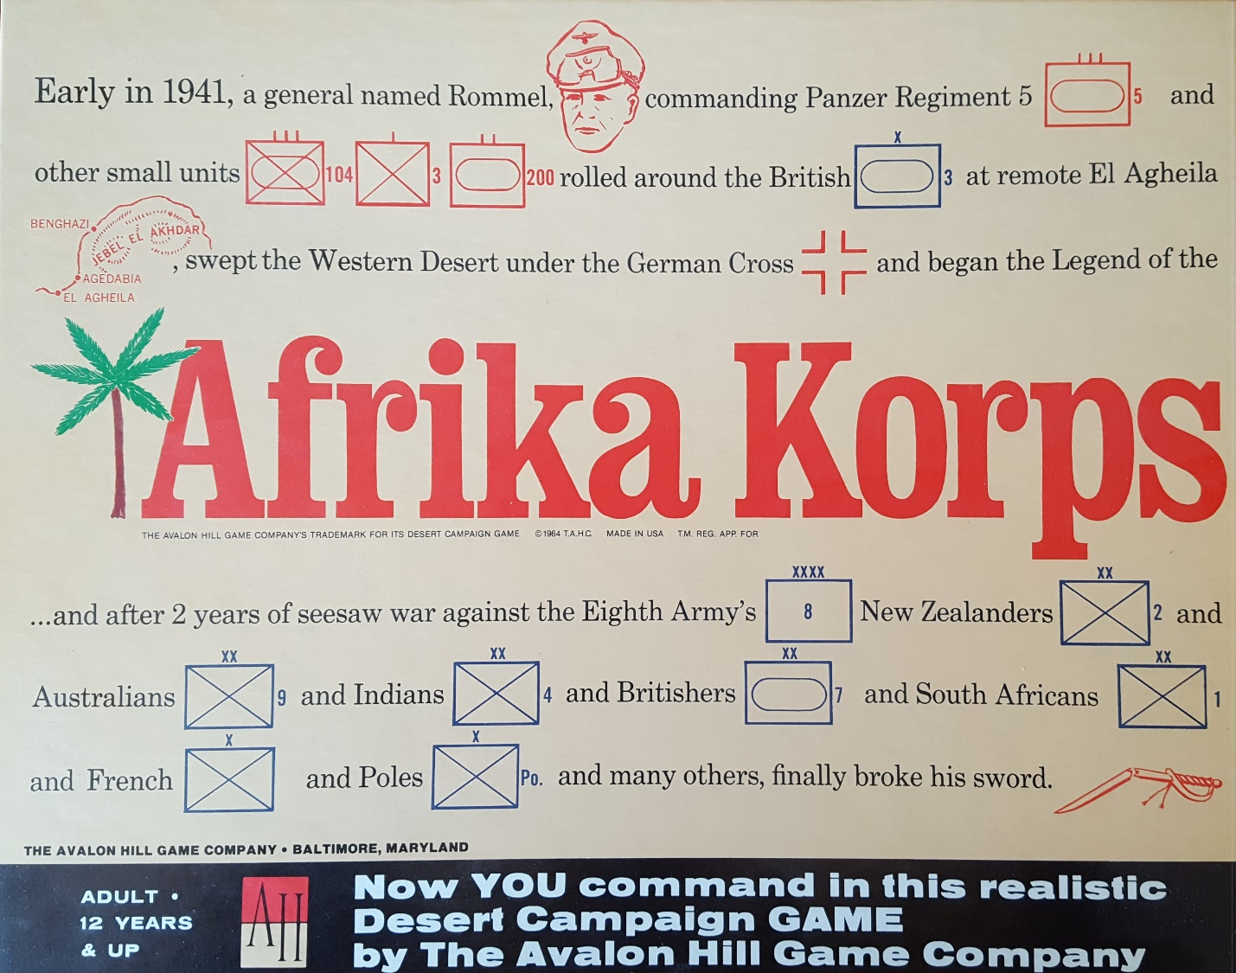

By Ed Menzel
October 2023

Introduction:
This primer is intended for new or inexperienced players. I originally intended to compile a compendium of old General Magazine strategy articles. But game play has advanced over the years and these old articles, while still having some good advice, advocated strategies with which I disagree. Rather than leaving it to the new player to sort out valid strategies from outdated ones, I decided to start afresh with my own article. I offer some basics approaches for each side in the game. I have included map pictures illustrating common positions for both players at various stages in the game. I do not claim that the examples in this primer are the best way to play the game. But they represent, at least in my opinion, one credible way to play the game.

Game Overview:
This is one of Avalon Hill’s Classic hex-based games from 1964. It is a well-balanced game. I will play either side as it comes out of the box – a rarity in many AH games.
Both players will need to continually count hexes to determine attack ranges of the opposing side’s units or to be sure a supply doesn’t get stolen.
To win, the Axis must eliminate all Allied combat units on board or control both fortresses and Home Bases for two consecutive turns by his last turn Oct 42 turn. If they do not, the Allies win. To achieve a victory, Rommel must capture Tobruch or the Allied Home Base by March 42. If he does not, the Allies will receive three replacement points to one for the Axis – a disadvantage the Axis can almost never overcome.
The Allies receive a supply every turn not to exceed four, plus any captured supplies. The Axis must roll for supplies starting on the second turn. This fundamentally affects the first half of the game as the Axis will frequently find they are unable to attack because of supply convoys that were sunk.
The Axis should attempt to overcome this limitation using the very mobile German units to threaten to outflank the Allies and forcing retreats by the Commonwealth. Rommel also has the threat of advancing after Automatic Victories against weak Commonwealth units.
The Allies should slow the Axis advance by placing a blocking 1-1-6 at key points on the Coastal Road while keeping other units out of range of attack. This forces the Axis to expend a supply to remove the blocker or costs time to remove the blocker through isolation. The Allies can well afford to trade one 1-1-6 for an Axis supply or two turns of delay.
The Axis have powerful units for attacks, but relatively few units. Losing more than two units in exchanges or soak off attacks will make protecting their flank in open territory such as El Alamein difficult. As a result, they want to attack at high odds to avoid exchanges and soak off losses. The Allies have mostly weak units and rarely can attack the Axis during the first half of the game. They need to defend on the doubled defensive terrain of the Tobruch perimeter with their heavier units to cause Axis exchange/soak off losses. After loss of the Tobruch perimeter, the Allies will need to rely on Coastal Road blockers, sunk supplies, the delay in getting Axis supplies from their Home Base to attacking positions in the east, and judicious withdrawals.

April – June 1941:
The Axis goal is to rapidly drive the Allies into Tobruch by their first June 41 turn to prevent the Commonwealth from deploying their June I armored units on the Tobruch perimeter. With average supply arrivals, they can usually do that with the possible exception of one or two hexes. Because runs of several turns with no new supply are common, Rommel should use supplies for attacks only where necessary such as on the Tobruch perimeter. Surrounding and isolating delay units will be necessary to advance while conserving supplies.
The Eight Army can generally defend on doubled terrain and screen open terrain with minimum forces against the light Axis forces they are likely to encounter.
Below are maps depicting game positions by turn with commentary that may be helpful.

41 04 I Allies 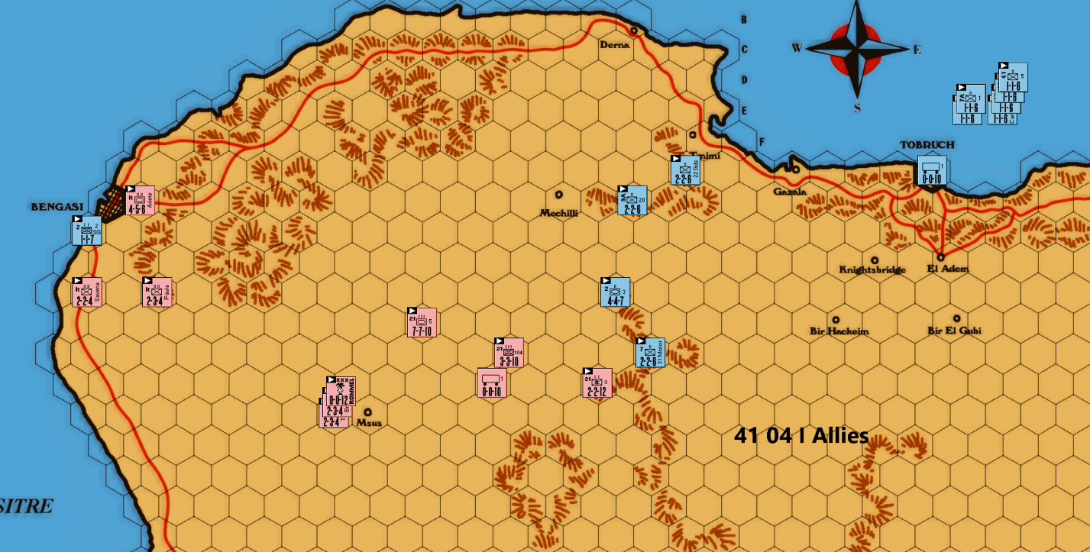
Off-map, the Axis have garrisoned their Home Base, and the Allies have sent a supply toward their Home Base. The map shows one Axis opening I have used. Two Italian 2-3-4s are sent into the open desert to form a line blocking any Allied penetration. There are a variety of Axis openings Rommel may choose but they have one thing in common – spread out the threats forcing the Allies to defend more areas than they are able. Another option is to send the 21st Panzer Division south and east to come at Tobruch from the south. In yet another option, Rommel and the 21st recce to east to U24 then R33. From there they can capture the Allied HB in two turns from an unwary Allied commander.
A common Allied response is shown occupying the western escarpment near Mechilli to block the Axis. All six 1-1-6s go to sea to assist in the defense of approaches to Tobruch next turn.

41 04 II Axis & Allies
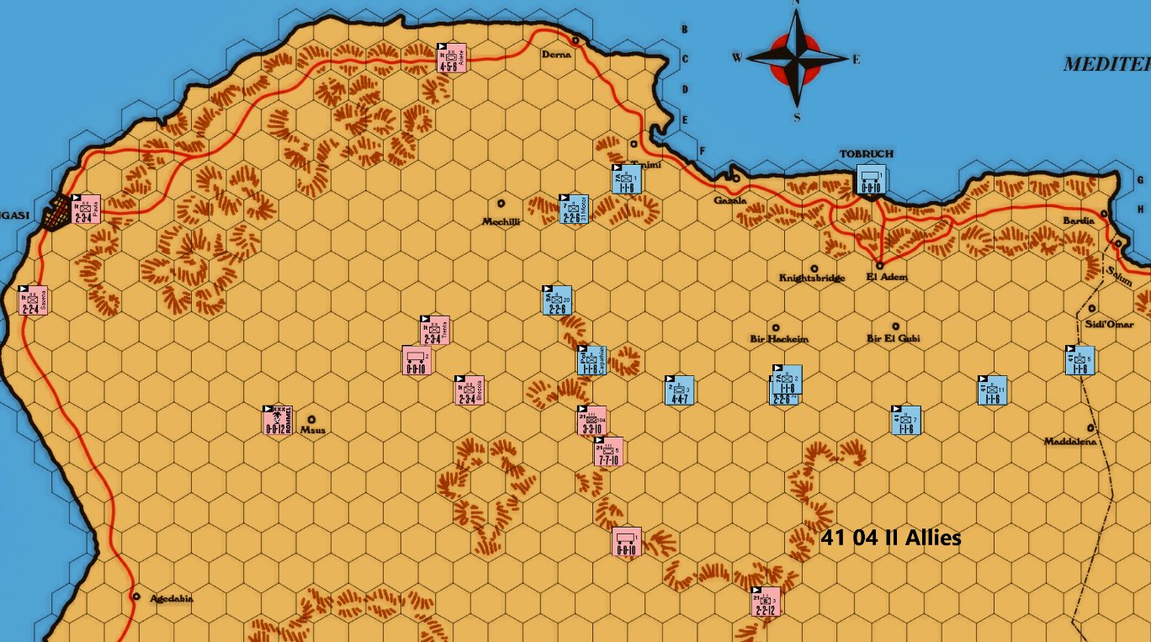
The Axis forces generally dictate the flow of the game and have several options as outlined with the April I turn. Here the 21st Panzer Division moves onto escarpment hexes with the recce moving further east to force the Allies to spread their defenses. The Axis should be reluctant to attack at 3-1 especially versus doubled positions. They can ill afford an exchange. And there is the risk of DB and a wasted supply.
The Allies must adapt their defense to counter the various Axis deployments as needed. But the objective is always the same – to keep the Axis away from easy advancements toward Tobruch. How many combat factors can the Axis put on each of the escarpment defensive hexes? The Allies should be willing to offer the unsurrounded 3-1 attacks for reasons just discussed. Here G18 can be defended with a single 1-1-6 allowing heavier units to be deployed elsewhere. The Allies spread out to defend the approaches to Tobruch.

41 05 I Axis & Allies
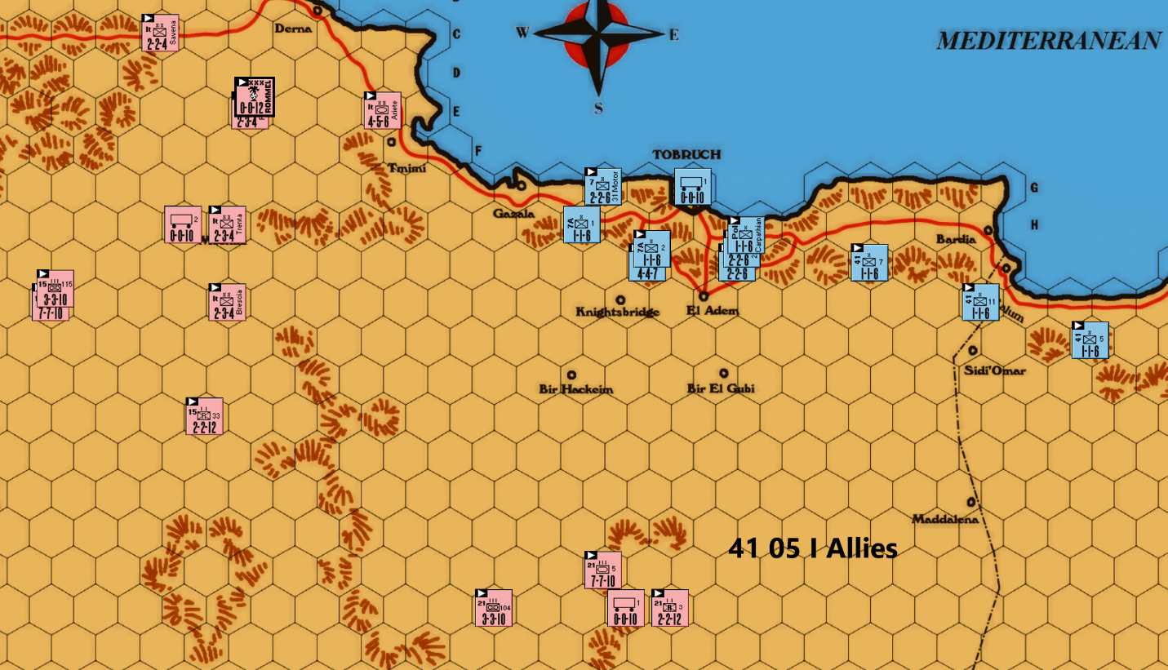
The 15th Panzer Division comes on board. 15/8 & 15/115 should end in the 11 or 12 file rows to have the shortest route to the Coast Road on the next turn.
The Allies have no choice but to withdraw and form a perimeter defense around Tobruch. The map shows a typical defense. Other reasonable defenses will have some variation in unit placement. A 1-1-6 should be placed with 2/3 armor to prevent a 3-1 attack from two hexes. If 2/3 is alone the Axis can attack it from J25 and J26, retreat 2/3 on a DB to H223, and advance. (The Axis must not have any of its units with a ZOC into H23.) 2/3 is now blocked from Tobruch. This is a 3-1 that has enough reward to be worth the exchange risk in my opinion.
This is one reasonable deployment when several Axis units have advanced as shown. Other Axis deployments will have to be examined for any adjustments in the Allied defense.

41 05 II Axis – attack option
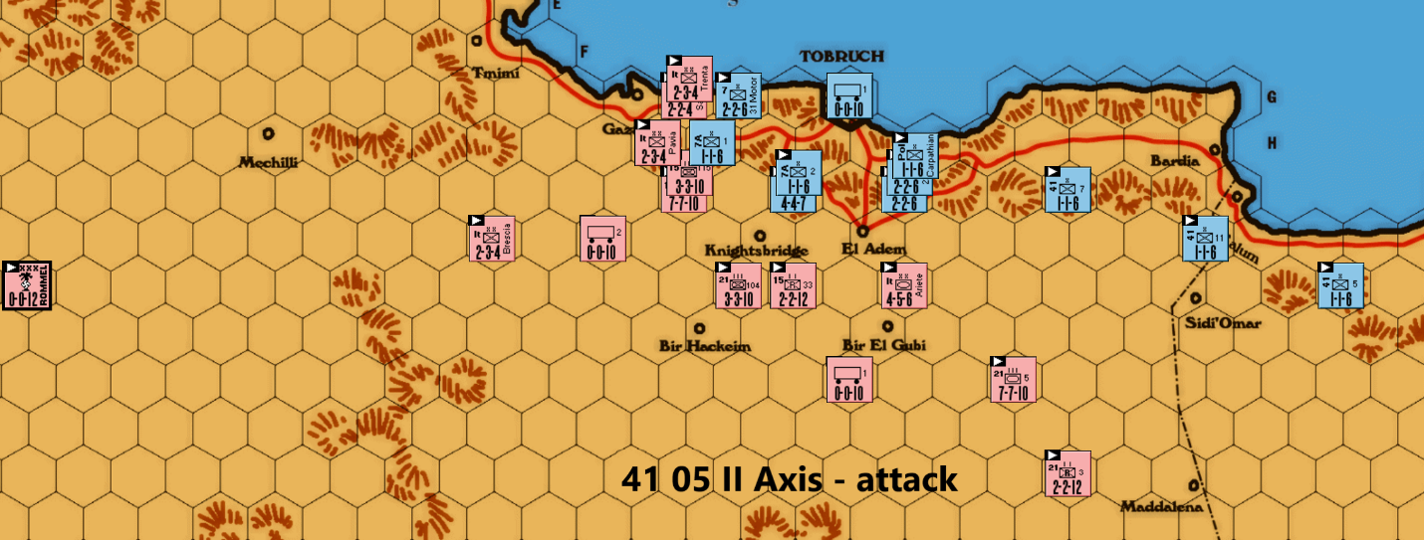
At this point, Rommel must decide if he stays at the front to aid in the Axis advance toward the Allied Home Base or head back to the Axis Home Base after providing some movement bonus. I favor going to the Axis Home Base so that one more combat unit is available in future turns.
The Axis should attack if they have three supplies on board. The Allies must be driven into Tobruch and the sooner that starts the better. I favor these attacks if any are made – an AV on the 1-1-6 and 1-2 vs 2-2-6 as shown on the map. The 1-2 has a 1/3 chance of DB which allows an advance into the vacated hex or an exchange which at this point if favorable to the Allies. If a DB/advance is achieved, then the Allies will have to yield the perimeter except for one picket unit. They would only be able to defend the Tobruch perimeter from two hexes. This would give the Axis too many good attack options. The best response is to place one 1-1-6 in H25, three big units in Tobruch, and withdraw the remaining units by sea of along the Coast Road. There is of course the 1/3 chance for an AE, but those are the risks of war. If there is no DB result, then the Axis will have to attack the perimeter again when they have enough supplies.
If the Axis have only two supplies on board, I favor no attacks. Just position to have more favorable attack options on the next turn. And certainly, with only one supply on board, no attacks should be made.

41 05 II Allies – No Attack
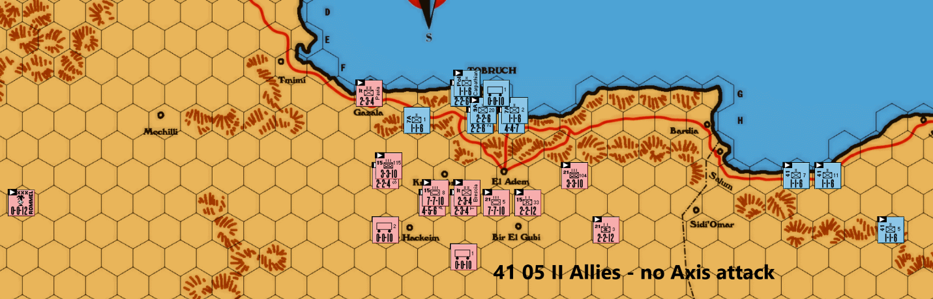
If the Axis do not attack on May II, then they should deploy in central positions with flexibility to attack with any units almost anywhere. This will force the Allies into a smaller perimeter to avoid surround attacks. The Allies should put two units in all three perimeter hexes to maximize defense while leaving a retreat hex for attacked units. A single 1-1-6 can be left in position to force the Axis to divert combat factors from more valuable units. Two units at J36 and J37 prevent a quick drive east on the Coast Road using an AV.

41 06 I Axis – no May Axis attack
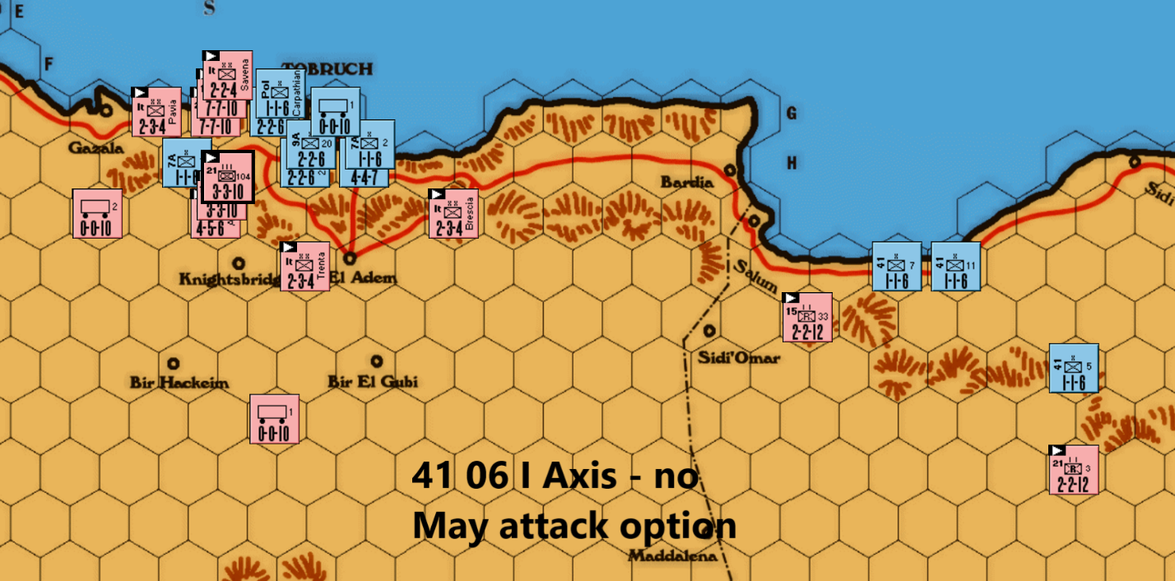
If Axis did not attack in May, then they would need to attack on their June I turn. This is one example. The Axis can only get two AVs and one soak off with one supply. They can attack the two eastern-most 1-1-6s or the two western-most 1-1-6s. I would choose the latter option as shown on the map since the soak off there is 1-3 vs 1-4 in the first option. The Axis will then have to eliminate a loan picket outside Tobruch before they advance east.

Go East Young Man, Go East
Once the last picket outside Tobruch has been eliminated, the Axis must decide whether to begin the assault on Tobruch or march east toward Alexandria. The Eighth Army has two 4-4-7s, one 3-3-7 and several 2-2-6s to defend Tobruch. On 3-1 attacks, there is a 2/3 chance for DE/DB, certainly favorable. But one early exchange will severely cripple the Axis.
I strongly recommend driving east to do as much damage to the Commonwealth as possible. This will be dependent on supply luck. If it is good, the Axis can eliminate a good portion of the Allied army. Bad luck and they will do only a modest amount of damage. But the Tobruch assault will still be there a few months later. There is no reason to rush into an assault in June/July. Every Allied unit eliminated now is one less unit to face down the road. The Axis can always double back for the assault later.

The Drive East
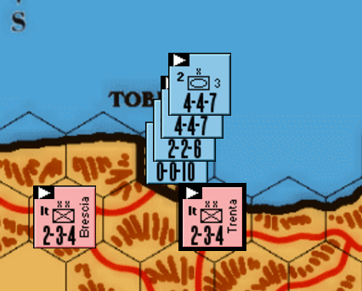
At this time there should be the 2-2-4 trundling down the Coast Road toward Tobruch from the Home Base. Until it arrives to reinforce the Tobruch perimeter defense, two Axis units should be used as shown in the map to guard Tobruch. Rommel must decide whether to send the 2-2-4 down the Coast Road to aid attacks on Allied positions or keep use it with the other two units to occupy all three hexes on the Tobruch perimeter.
The drive east will be typified by Allied blocking units along the Coastal Road and Axis forces choosing between AVs against the blockers and eliminating them through isolation. In the following maps, I illustrate some common Axis maneuver/attack and Allied blocker positions. Each game will be a little different, but they are representative of typical deployments. Study these and apply the principles to your game.
There are a few things worth mentioning regarding this phase of the game. I almost never attack on this drive unless I have a second supply within a one-turn march to support another attack. If there isn’t one that close, you are going to have to wait at least a turn anyway before continuing the assault. And if you do attack without another supply close by, the Eighth Army gets a free shot at the DAK without having to worry about a counterattack.
The second consideration comes into play as you progress further east. Unless the Axis can continue their attacks near El Alamein, it is prudent to keep the Axis heavies within a one-turn march to Tobruch. Otherwise, the Allies can land armor from the Tobruch defenses and attack the DAK without worrying about an attack on Tobruch.
I favor the Allies garrisoning Tobruch with both 4-4-77s and a 2-2-6. The 3-3-7 and other 2-2-6s are used for defense of the Coastal Road/Home Base. If the Axis progresses east such that they cannot reach Tobruch in one turn, the Allies can put one 4-4-7 to sea and then swap with the other 4-4-7 next turn. That way there is always one 4-4-7 that can land in the east and assist in any attack opportunities that may present themselves.
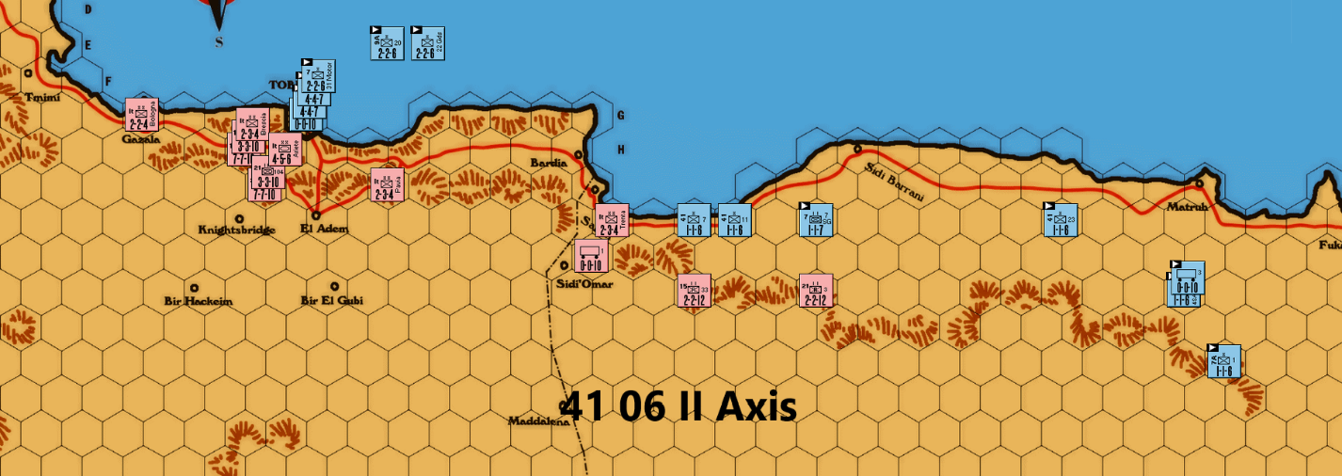
In this map, the Axis have eliminated the last Allied Tobruch perimeter defender and are ready to move east. The Allies placed a 1-1-6 at J36 and J37. This blocks the Coast Road. The Axis may expend one supply to AV one unit which they should not do or maneuver to isolate the Allied position and accept the delay. This is a tactic the Eighth Army will need to use on future turns as well.
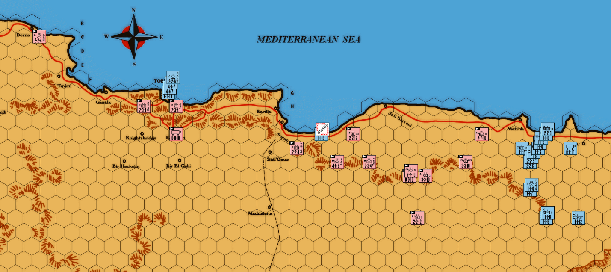
On this map, the Axis have isolated the blocker. The Allies have withdrawn such that a supply used to AV the blocker is not within range to attack the force near Matruh. This is a primary tactic of the Allies – offer one unit and stay out of range of attacks on his other units using only one supply. A second point worth pointing out is the one 1-1-6 at K49 who blocks more than one hex for the Axis attacks on the flanking defenders. This type of defense can also be used 3 hex rows further west.

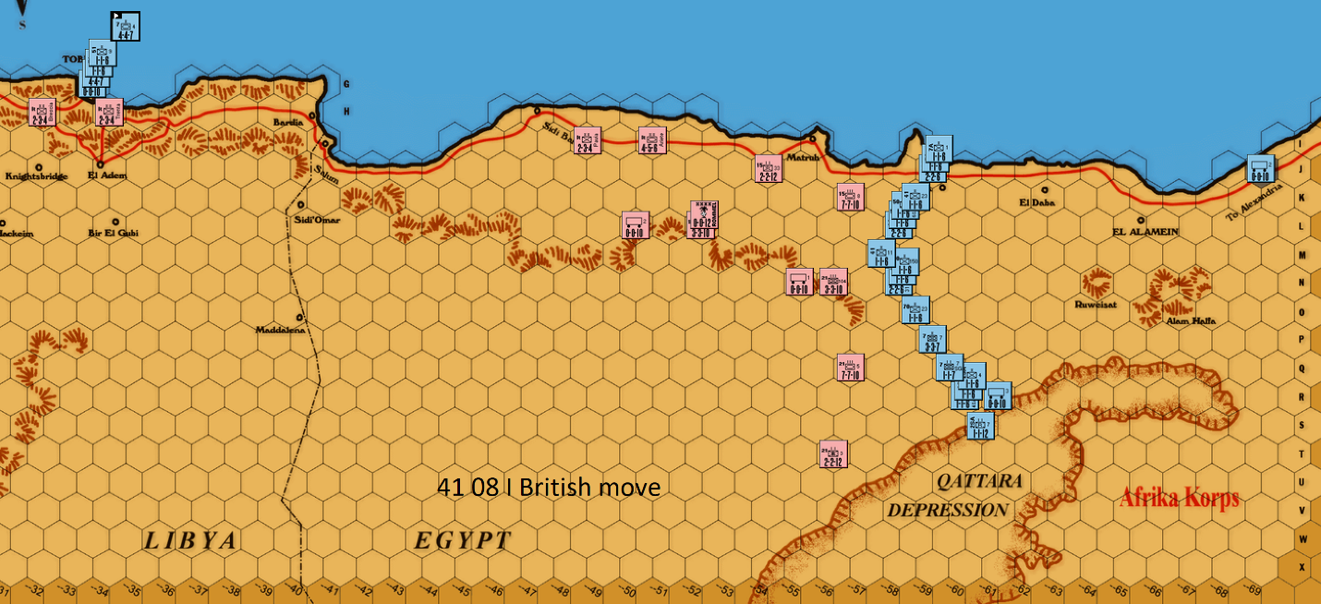
Here is an example of an Allied defense east of the escarpment. This chevron defensive pattern can be used in hex rows further east as well.

Continue East or Assault Tobruch – and When
In the September/October 41, the DAK will have to decide whether to continue to drive toward Alexandria or turn back for the assault of Tobruch. The Axis do not have to take the Home Base before the Allied November reinforcements arrive to make a continued drive worthwhile. If they can force the Eighth Army into a small perimeter around their Home Base, that is a commanding position! Even with the November reinforcements, the Eighth Army will be hard pressed to achieve much against the powerful Axis units.
If the DAK drive east has not caused major Allied attrition losses (this is usually the case), an assault on Tobruch must be made. Then the question becomes, when. Rommel must take Tobruch before March I or II 42 as the 3-1 replacement advantage the Eighth Army would enjoy is virtually always fatal to the Axis cause. The Axis can assault Tobruch before the Commonwealth November reinforcements arrive or afterward but before March 42. There are advantages to each. In the pre-November period, there are two 4-4-7s, one 3-3-7, and several 2-2-6 units available for defense of the fortress. The Allied November reinforcements add two 4-4-7s and multiple 2-factor units which would argue for the earlier assault. However, the Axis add four units/10 factors themselves in November to better withstand losses. The added factors allow for tolerance of one additional exchange versus a 4-4-7.
I would argue that the Axis can withstand one exchange in the pre-November case against two 4-4-7s and one 3-3-7; and two in the post-November case against the four 4-4-7 and one 3-3-7 units. More than that, plus the soak off losses will make for a tough road for the DAK. The probabilities for each case can be calculated and compared. Admittedly this is a significant oversimplification of the overall chances of taking Tobruch. But for evaluating which option is better, I think it provides a good assessment.
I’m defining a “Good Result” and “Tolerable Result” with the appropriate numbers of exchanges noted in the table below. The assaults consist of consecutive 3-1 attacks versus each of the Allies armored units with appropriate soak offs against the remaining Tobruch defenders. The probabilities for each result are shown.
Pre-Nov Assault Probabilities  For three 3-1 Consecutive Attacks  VS. 2x4-4-7 & 1x3-3-7 |  | Post Nov I Assault Probabilities  For five 3-1 consecutive attacks vs  4x4-4-7 & 1x3-3-7
Good Result  0 EX | Tolerable Result  1 EX | Good Result  0-1 EX | Tolerable Result  2 EX
30% | 44% | 46% | 79%

This analysis suggests that the post-November assault is the noticeably superior choice for the Axis. The percentages shown are for the likelihood of the noted number of exchanges. These are not the probabilities of taking Tobruch. Other factors such as soak off losses and results of attacks versus the two-factor units will affect the Tobruch capture probability. But for the purpose of selecting which option is preferred, I think it is a good guide.
Once Tobruch has fallen, the Axis can start to drive east again. The earlier maps of the fight along the Coastal Road can be used to guide play for both players.

